**Patterns and Explanations of Policy Change under the Advocacy Coalition Framework**

By

Christopher M. Weible, Allegra H. Fullerton, Kayla M. Gabehart, Tanya Heikkila, Karin Ingold, Elizabeth Koebele, and Daniel Nohrstedt

**Abstract**

This paper asks the following question: What are the patterns and explanations of policy change? Guided by the Advocacy Coalition Framework, a new conceptualization of major and minor change was developed and presented to answer this question. This paper introduces a new 2x2 that distinguishes between the type of change (policy core to secondary change) and the scale of change (contributions to the policy sub-corpus). The four categories of policy change lie on a spectrum: major policy core change, minor policy core change, major secondary change, and minor secondary change. It then tested two hypotheses with confirmations for both. In Colorado's oil and gas development from 2007-2020, the findings show that most changes were minor secondary changes, with moderate amounts of minor policy core changes and major secondary changes. The significant explanations for changes include internal events and changes in the government (i.e., the governorship). The conclusion presents the next research agenda based on the limitations of this study.

Paper prepared for the 6th International Conference on Public Policy (ICPP)

Toronto, Canada

June 27th - June 29th

**Introduction.**

The study of policy change has fascinated scholars of public policy for decades. For some, policy change represents the inspirational idea that societies can adapt to shifting priorities and problems, addressing their worst maladies. For others, policy change represents the ultimate puzzle, involving theoretical and empirical explorations into patterns of both description and causal explanations. Still, others approach policy change as a springboard to studying societal effects and impacts.

Thus, a tome of research exists on the phenomenon of policy change. This literature spans the theoretical in general and specific depictions of policy change, often as policy outputs (Easton, 1965; Hofferbert, 1974). It includes questions of what changed, which helped spawn the development of typologies (Lowi, 1972; Mahoney & Thelen, 2009; Hall, 1993), studies of patterns of change (Baumgartner & Jones, 1993), and arguments about the meaning of change (Lasswell, xxxx). It helped spur studies of policy design, instruments, and tools (Howlett, 20xx; Siddiki et al., 2022; Knill).

As part of this literature and a decades-long contributor, the Advocacy Coalition Framework remains one of the most established theoretical approaches for analyzing policy change, from Sabatier (1988) to Nohrstedt et al. (2023). As such, the ACF has advanced knowledge about policy change, primarily pointing to the importance of the explanations of change, such as internal or external events, learning, negotiated agreements (i.e., “hurting stalemates,” changes imposed by a higher jurisdiction, or changes in the coalitions governing the subsystem. Indeed, evidence to date unequivocally confirms at least one of the explanations without any refutations of the ACF’s expectations.

Yet, the meaning of continuous confirmations is not always a point of triumph. While never refuting hypotheses might signify a discovery of truths, in the case of the ACF, it is more likely a reflection of underdeveloped theory and concepts, vaguely stated hypotheses and unsystematic and transparent methods. Indeed, the concerns about the sub-literature under the ACF raise several limitations, many of which this paper attempts to address.[1]

First, the ACF lacks any clear, reliable, replicable, or public method for operationalizing policy change. While recent efforts have emerged for explaining policy change (Nohrstedt et al. 2021; Fullerton et al. 2023), no common protocol has been adopted and, as a result, no meaningful comparisons exist.

Second, more precisely than the first point, the ACF lacks conceptualization and operationalization for distinguishing major and minor changes. As described in the theory section, these two concepts have definitions but attempts to operationalize them have yet to be successful. The purpose of this paper is to provide one reliable and replicable method.

Third, there is theoretical obscurity in what explains major and minor policy changes. The ACF’s hypotheses of policy change tend to focus on major change and not a minor change, yet many of the explanations that explain major change also explain minor change. One often-used explanation is that learning is associated with minor policy change, and external events are associated with major policy change; however, evidence shows that these associations are not exclusive, and the relationship is far more complex. This paper provides a new conceptual and operationalization of major and minor changes.

Fourth, major and minor changes are often depicted as a dichotomy; either a policy change is one or the other. However, of course, the world’s complexity rarely makes for dichotomies. This paper develops a new conceptualization of policy change and studies it as a spectrum and discrete categories for simplicity's sake.

Fifth, a vast major of policy change research focuses on a single instance of policy change and not multiple policy changes or what can be imagined as an evolution of policy changes in a policy subsystem over time. Isolated studies make it difficult to discern major and minor changes, which are also susceptible to “cherry picking” by scholars of the most salient policy decisions, thereby giving skewed insights into explanations of change.

This paper aims to revisit the meaning and methods of policy change in the ACF. It asks the fundamental question: What are the patterns and explanations of policy change? In answering this question, this paper reviews the foundations of the ACF’s major-minor change concept, critiques it, and provides novel conceptualization and methods with indicators and measures for analyzing it. We then illustrate this technique in the context of oil and gas development in Colorado, USA.

**ACF’s Theory of Policy Change and a Reconceptualization of Major and Minor Poilcy Change**

The ACF is a framework that provides a basic infrastructure to view the policy process with its general concepts, relations, and questions. This paper does not give a detailed description of the ACF; for one, see Nohrstedt et al. (2023). Instead, it focuses directly on one of ACF’s theories in policy change and brings only the necessary materials to make and test the hypotheses. This section is divided into two subsections, one on ACF’s current theory of policy change and the other in presenting a revised conceptualization of major and minor policy change, which is then elaborated on via methods and illustrated via the empirical results section.

*ACF’s Theory of Policy Change*

Nohrstedt et al. (2023, pg XXX) state, “Policy change can refer to any decision to adopt a public policy, including laws, regulations, programs, legal decrees, and executive orders that represent the goals of one or more of the coalitions within the subsystem.” In other words, written public policies. It deals with policymaking venues with authority (i.e., those formulating and adopting the policies listed above), which could be within and outside a government.

From here, the ACF offers two sets of explanations of policy change in two hypotheses, both related to policy core changes.[2] The first focuses on four pathways: external events, internal events, negotiated agreement/hurting stalemate, and learning. The second deals with changes in the advocacy coalition that instated the programs or changes hierarchically imposed from outside the subsystem. The mechanisms of these explanations are not deterministic but probabilistic; for example, any given pathway does not necessarily lead to policy change. There needs to be an “exploitive coalition” to capitalize on these opportunities (Nohrstedt et al., 2023; pg xx). Furthermore, the explanations of policy change need not happen independently; for example, an external event may lead to a coalition learning leading to policy change.

The ACF specifies two types of policy change: major and minor. The conceptual difference between them is linked to the ACF's main unit of analysis in the policy subsystem and the belief system concept. For the former, the policy subsystem refers to a policy issue's substantive and geographic scope, such as Colorado's oil and gas policy subsystem. For the latter, the ACF's belief systems consist of three tiers. Deep core beliefs are the most available tier consisting of normative, axiomatic, and ontological values and identities. Policy core beliefs are in the middle and consist of normative and empirical beliefs generally related to the policy subsystem, such as general views of the policy and problems. Secondary beliefs are the narrowest and deal with instrumental beliefs, such as achieving the policy core or beliefs of a narrow subset of the policy subsystem. Theoretically, the ACF argues that the rigidity of belief systems spans from the most rigid in deep core beliefs to the more pliable in secondary beliefs. For the ACF, major change is associated with changes in the “policy core” of a policy subsystem and minor change is associated with changes in the “secondary aspects” of a policy subsystem.[3]

A vast major of ACF studies has confirmed the explanations of policy change (Weible et al., 2009; Jang et al., 2016; Li & Weible, 2019; Pierce et al., 2020; Osei-Kojo et al., 2022). In other words, studies unequivocally find at least one of the explanations for policy change. However, as mentioned in the introduction, this ostensible strength is also a weakness – if empirical research has never refuted ACF’s hypotheses of policy change, are they really that helpful in advancing knowledge about policy change? The answer is partly. The ACF’s explanations of policy change have advanced the literature, but knowledge has plateaued, hence the need to revisit its concepts and introduce better methods.

**Revised Conceptualization of Major and Minor Policy Change**

Before revisiting the ACF’s conceptualization of major and minor policy change, it should also be noted that the ACF’s belief system concept (which anchors its definitions of major and minor change) has evolved (e.g., see discussion in Sabatier and Jenkins-Smith, 1999; pg 132). The intent of conceptually revising the belief system concept was to aid in measuring belief systems, particularly in surveys and textual analysis, such as legislative testimonies. This refinement is essential to mention because it serves as a reminder that frameworks evolve. It also shows that the belief system concept was never developed or revised to help study or distinguish major and minor policy changes.[4]

This paper introduces the following definitions to re-conceptualize major and minor policy change, especially towards developing reliable methods.

“Policy corpus” A policy corpus refers to the compilation of public policies that shape and comprise a policy subsystem and the target of advocacy coalition behavior. Studying an entire policy corpus would be impossible and, if possible, unwieldy (for example, it might draw in a country’s constitution and everything down to the relevant local ordinances). Instead, most studies sample and examine “sub-corpora” or subsets of the policy corpus (e.g., by time, venue, proximity, or other). For example, this study analyzes all legislation on oil and gas development from 2007 through 2020 in Colorado; it does not study Colorado’s court decisions, constitution, local ordinances, regulations, etc.

“Policy components” The policy components refer to the parts of a policy corpus or sub-corpora that comprise their whole. The measurement of policy components may vary by study. In this study, the policy components consist of the instruments, targets, authority, and topics (with inspiration from Sabatier and Jenkins-Smith, 1999; pg 133; Fernández-i-Marín et al., 2021; Siddiki et al., 2022).

“Secondary change”Secondary change refers to changes to any policy sub-corpus that adjusts or modifies policy components but does not add new components. This definition is a relatively direct translation of secondary policy change as changes to the instrumental aspects of a policy subsystem or the means for implementing the policy core of a policy subsystem (Nohrstedt et al., 2022; pg xx).

“Policy core change” Policy core change refers to adding a new policy component to a policy subsystem's sub-corpus. This definition is implied from the secondary change above.

“Major and Minor change” *Major or minor policy change* is defined as the contributions of a policy through adding or modifying components in a policy sub-corpus. One way to distinguish major and minor policy change, as done in this paper, is through calculations of change above or below one standard deviation of the mean change for all policies.

The new concepts and redefinitions are essential for several reasons. First, there needs to be a recognition of a policy corpus or sub-corpus to measure whether a policy adds something new or revises something existing (distinguishing between secondary and policy core change) – the difference between policy core and secondary change is dependent on the nature of the sub-corpus sampled. Second, there needs to be a term to describe the parts of a policy sub-corpus used as the units of observation and for analyzing change. While this study analyzes instruments, targets, authority, and topics, it is possible for a study to develop different policy components. Third, a distinction is needed between major and minor change and secondary and policy core change. That is, a single change from an adopted public policy in a policy core of a policy sub-corpus might be a policy core change. However, it might be a minor policy core change compared to many changes in the policy core of a policy sub-corpus from a different public policy, which might be major policy core change.

These new and revised concepts, thus, allow for the creation of a 2x2 in Table 1, which summarizes four primary categories of policy change in a sub-corpus. The vertical dimension refers to the scale of change (major to minor), and the horizontal axis refers to the type of change (secondary to policy core). This results in four categories of change: major secondary change, minor secondary change, major policy core change, and minor policy core change. Of course, these four categories could be measured as distinct categories or as spectrums – this paper does both.

**Table 1. Four Primary Categories of Policy Change in a Sub-Corpus**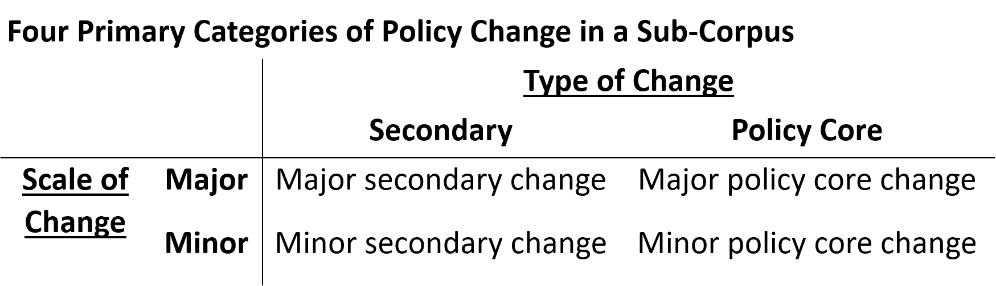

From Table 1 and building on the theoretical logic in the ACF and Punctuated Equilibrium Theory (Baumgartner & Jones, 1993; Jones & Baumgartner, 2004), the ACF posits the policy distribution of policy change hypothesis.

**Distribution of Policy Change Hypothesis** A policy sub-corpus will show most frequently minor secondary changes, a moderate amount of minor policy core and major secondary changes, and the least amount of major policy core change.

Following the logic of the ACF, this first hypothesis recognizes that policy core changes are more difficult than secondary changes and that major policy changes are less likely to happen than minor ones. The least likely category is major policy core change – relatively many new components added to a policy sub-corpus. The most likely policy change is minor secondary change – relatively few modifications to existing policy components of a policy sub-corpus.

The first part of the results tests the distribution of the policy change hypothesis above. The second part of the results explains policy change for the different categories. Given that the ACF’s hypotheses are anchored to changes in the policy core aspects of a policy subsystem (see Footnote above), this paper tests a simplified version of the ACF’s two policy change hypotheses to capture any change category in Table 1. For simplicity, this paper also interprets changes imposed by a superior hierarchical jurisdiction, which equates with the ACF’s external events category of changes in a governing coalition, as an additional pathway.

**Explanation of Policy Change Hypothesis:** Policy change will be follow a combination of least one of the following: internal events, external events, learning, negotiated agreement/hurting stalemate, or changes in a governing coalition.

Of course, all the changes posited in the hypothesis above also necessitate an exploitative coalition. This condition points to the ACF leaning towards its case-study roots, that is, the tendency to study one instance of policy change through thick descriptions of the surrounding politics. This study might be of a single policy subsystem. However, it is also of over two dozen instances of policy change, making it infeasible to analyze exploitative coalitions in each case. Moreover, this study is not analyzing instances of non-change; but, as described in the methods section, relies on an “inductive subjective analysis” to identify the antecedents of policy change (see Fullerton et al., 2022). The point of raising this limitation in the theory section is to underscore that ACF’s theories are often case-study based, meaning it favors single case studies. Yet, many of its arguments also require relatively large-n analyses of many policy changes that offer opportunities for very different theoretical insights in advancing the field but do not offer some of the advantages of a case study of a single instance of policy change.

**Context**

We focus on passed legislation in the state of Colorado’s oil and gas subsystem between 2007-2021 (n=30). Furthermore, we focus specifically on public policies adopted in response to debates and concerns around unconventional oil and gas development (hydraulic fracturing or fracking). Hydraulic fracturing is a technology that revolutionized oil and gas development in the early 2000s by fracturing underground rock using water, sand, and chemicals to extract oil and gas from small, isolated pockets. The introduction of horizontal drilling further allowed oil and gas development to become profitable and expand to previously unfeasible areas. These new technologies created a surge of economic activity which exacerbated conflicts, embroiling state and local governments, citizen groups, environmental groups, industry, and scientists (Weible et al., 2016). During this time, the state of Colorado responded with a flurry of policy changes to regulate fracking.

**Methods**

We identified thirty policies passed by the Colorado State Legislature between 2007-2020 by searching for key words “fracking” “xx” “xxx” in the Colorado legislature website (<https://leg.colorado.gov>). These policies were downloaded and converted to text files which we uploaded into Discourse Network Analyzer v3.10 (Leifeld, 2023). We subsequently coded each policy and identified policy statements which include three categories: the *topic* of the policy, it’s *instrument or authority*, and its *target*.

The topic of the policy describes what the policy is about and we identified 34 different topics in our sample. These range from penalties, appropriation, spills, to governance. Most bills had one topic, although a few had more than one, for instance SB1083 from 2008 had statements about mineral rights and taxation. Each policy statement must include either an instrument or an authority. Instruments include the “techniques of means” by which a policy attains its goals and involves the extent of behavior change (Howlett, 2020, p. 22). They represent a general typology of different types of “causal theories” (Mazmanian and Sabatier, 1983). A policy may include one or more policy instruments. Policy instruments are classified as one of the twelve categories from the Average Instrument Diversity (AID) Index (Fernández-I-Marín et al., 2021)[5]. Certain policy statements gives or restricts power, which we coded as authority. We identified eleven different authority codes, ranging from the authority to convene, to produce, to regulate. Finally, we identified the target of the policy statement, that is the actors who are impacted by the policy instrument/authority. These ranged from various state agencies to owners to indigenous community members[6]. The coded statements were then exported as an event list to excel where it was converted into a two-mode matrix which included the topic, instrument/authority and target for each policy.

Various parts of our analysis also draws upon the antecedents, or an expression by a policy actor in the public discourse of anything that happens before the policy change and is somehow linked to policy change through their language (Fullerton et al, 2023). Examples of antecedents can include (but are not limited to) references to events, responses from other governments, citing new information, citing prior policy decisions, and more[7].

The identification and coding of antecedents leverages both an inductive and deductive approach. We maintain a wide net in collecting antecedents, but we code them according to common categories in the literature on policy change, including the ACF and beyond. Antecedents were identified when we read or heard specific evidence of an actor saying or inferring why or what lead to a policy change. We then categorized the coded antecedents into two broad categories, either an external reference which refers to something outside the subsystem’s scope or internal refers to something inside the policy subsystem’s scope. We also identified several sub-categories which relied on the existing ACF subcategories as well as other policy theories of policy change including crisis/disaster, mobilization, learning, or reference to past policy (past policy failure).

**Results**

Within our 30 policies, we identified 254 statements which all included a topic, instrument/authority, and target. Figure 2 and Table 1 are used to test hypothesis 1 and 2, respectively.

Hypothesis 1 argues that the distribution of policy change will be primarily minor secondary change, moderately major secondary and minor policy core, and rarely major policy core. Figure 1 confirms this hypothesis. It shows a scatter plot with percent policy core changes on the horizontal axis from 0% (all secondary change) to 100% (all policy core change). Percent change to the policy sub-corpus is presented on the vertical axis from 0.004% (the minimum change in the data) to 28% (the maximum change in the data). Two lines are added to delineate the scatter plot into four quadrants: minor secondary change, minor policy core change, major secondary change, and major policy core change. These lines are based on mean per axis plus one standard deviation.

The results show a skewed distribution (skewness = 2.24) and kurtosis (5.06) (for both axes combined). Most policy changes (n=24) fall in the bottom left quadrant, where secondary change is higher than policy core changes. Two policies fall in the upper left quadrant where major secondary change happens, where there is a lot of secondary change but not so much policy core change. The bottom right quadrant is minor policy core changes with four policies, those with major policy core changes but not so many component changes to the policy corpus. Finally, no instances of major policy change occur in this sample (the upper right quadrant is zero).

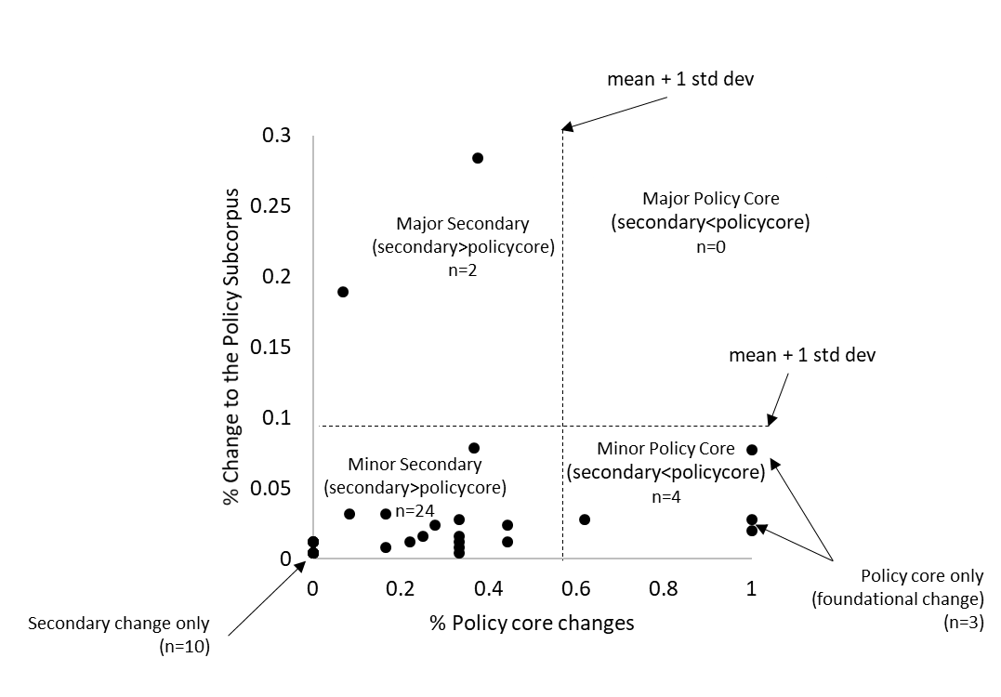**Figure 2. Distribution of Policy Change and an Empirical Evaluation for Hypothesis 1**

Three additional peculiarities emerge from Figure 1. First, three of the four minor policy core changes were "foundational changes," which are changes to the first year of policy adoptions in this sub-corpus. The reason is simple; these policies had a first adoption advantage in being the first to lay out policy components, establishing the policy core to the subsystem. Any additional policies had to add to this foundation. The second is the ten instances of minor secondary change without any policy core. These policies had nothing original but just added to the policy sub-corpus. Third, the major difference between major secondary and minor policy core might be timing. The two policies falling in the major secondary change were SB181 and HB1266. Both ostensibly change the policy subsystem's structure but revise and change existing policy components. This re-conceptualization of policy change suggests that a type of "major policy change" might be tweaking existing policy components as done.

Table 1 provides evidence to test the second hypothesis, which seeks to assess the relative effects of the independent variables posited by the ACF on policy change. Whereas the policy change data come from the legislative policy content, these data come from the public statements by policy actors explaining policy change.

The dependent variable comes directly from Figure 1. The first model calculates the Euclidean distance from any two policies in Figure 1, creating a 24x24 matrix with values treated as continuous. Given the interdependence of the observations, Model 1, a Multiple Regression Double Dekker Semi-Partially model, was conducted for the distance matrix consisting of percent policy core and percent major and minor change from Figure 1; that is, a 24x24 symmetric matrix with each cell indicating the Euclidean Distance between any two instances of policy change on the scatter plot. For Model 2, a Logistic Regression Double Dekker Semi-Partially model was conducted for the binary matrix, a 24x24 symmetric matrix with each cell indicating the same category of policy change; that is, do any two policies appear in the same quadrant in Figure 1. Standardized coefficients are reported for Model 1, and odds ratios are reported for Model 2.

The results are consistent across models, with internal events and governorship being significant explanatory variables. A one standard deviation increase in stated internal events leads to a .20 standard deviation decrease in the distance between any two policies in Figure 1. For model two, the odds of being in the same policy change category increase 16 times with every unit increase in internal events. The insignificant independent variables in Table 1 include external events, learning, and party control of the legislature.

**Table 1. Explaining Policy Change and an Empirical Evaluation of Hypothesis 1**

|  |  |  |  |  |
| --- | --- | --- | --- | --- |
|  | Model 1: Distance Matrix | | Model 2: Binary Matrix | |
|  | Std. Coef. | P-Value | Odds Rat. | P-Value |
| External events | 0.08 | 0.23 | 0.38 | 0.14 |
| Internal events | -0.20 | 0.04 | 16.0 | 0.02 |
| Learning | 0.06 | 0.15 | 0.61 | 0.12 |
| Governorship | -0.18 | 0.02 | 3.32 | 0.04 |
| Party Control Legislature | 0.08 | 0.12 | 0.80 | 0.41 |
| Control: Total Words | 0.49 | 0.01 | 0.25 | 0.01 |
| Control: Ratio New-to-Old Words | -0.14 | 0.05 | 1.60 | 0.05 |
| Adjusted R2= | 0.34 |  | 0.38 |  |
| Note: For Model 1, a Multiple Regression Double Dekker Semi-Partially model was conducted for the distance matrix consisting of percent policy core and percent major and minor change from Figure 1; that is, a 24x24 symmetric matrix with each cell indicating the Euclidean Distance between any two instances of policy change on the scatter plot. For Model 2, a Logistic Regression Double Dekker Semi-Partially model was conducted for the binary matrix, a 24x24 symmetric matrix with each cell indicating the same category of policy change; that is, do any two policies appear in the same quadrant in Figure 1. Standardized coefficients are reported for Model 1, and odds ratios are reported for Model 2. | | | | |

**Conclusion**

This paper asks the following question: What are the patterns and explanations of policy change under the ACF? A new conceptualization of major and minor change was developed and presented to answer this question. It created a 2x2 that distinguished between the type of change (policy core to secondary change) and the scale of change (contributions to the policy sub-corpus). The four categories of policy change lie on a spectrum: major policy core change, minor policy core change, major secondary change, and minor secondary change. It then tested two hypotheses with confirmations for both. In Colorado's oil and gas development from 2007-2020, the findings show that most changes were minor secondary changes with moderate amounts of minor policy core changes and major secondary changes. The significant explanations for changes include internal events and changes in the government (i.e., the governorship).

The principal contribution is the new conceptualizations of minor and major policy change and a method for finding their relative distribution in a sub-corpus of policy changes and their explanations. It is the hope of these conceptualizations and methods that the ACF literature can take a big step forward in advancing our knowledge of policy change comparatively.

New conceptualizations and methods also point to new research opportunities, many of which can build on the current study's limitations. First, this study focused on Colorado's single oil and gas policy subsystem. While the expectation is high that the distribution of policy change found herein will tend to hold across many types of policy subsystems, there is much uncertainty regarding the explanations of change (i.e., will internal events dominant explanations of policy change in a policy sub-corpus compared to external events?). This prompts the need for replication of these to other policy subsystems worldwide.

Second, this study also studied a policy sub-corpus drawn from a legislature. Whether the patterns found herein match other policymaking venues is an open question. Even in Colorado’s oil and gas subsystem, one of the next steps is to analyze the distribution and explanations of policy change in other policymaking venues, such as executive orders or regulations.

Third, this study draws on a relatively large sample of policy changes, about a dozen. Its analysis of the content via the manual coding of policy components and its inductive extraction of explanations of policy change via public statements by policy actors all require further confirmation through other data sources. Of course, in an ideal situation, all studies of the ACF or any policy theory would involve multiple methods of data collection and analysis in the short and long term – this, however, is unfeasible. Still, relatively large samples of policy change would benefit from deep dives, qualitatively into smaller samples of policy change, to confirm their results, particularly the explanations of policy change or the interpretation by policy actors of what major and minor or policy core and secondary changes mean.

1. Another limitation to this literature is the tendency for policy outcomes and policy change to be conflated while they are different. The study of policy outcomes requires analyses of implementation and feedbacks, evaluation of impacts compared to baselines, and research designs enabling comparisons. The study of policy change is the study of what, how, or why a government decided to adopt a policy (or not adopt a policy). It is not the study of the impacts of those (non-)decisions. Both of these are important and the ACF’s effort is primarily on the study of policy change to the neglect of policy outcomes. This study focuses on policy change not policy outcomes.
2. Nohrstedt et al. (2023; pg xx) state them this way. Policy change hypothesis 1: “Significant perturbations external to the subsystem, a significant perturbation internal to the subsystem, policy-oriented learning, negotiated agreement, or some combination thereof are necessary, but not sufficient, source of change in the policy core attributes of a governmental program.” Policy change hypothesis 2: “The policy core attributes of a government program in a specific jurisdiction will not be significantly revised as long as the subsystem advocacy coalition that instated the program remains in power within that jurisdiction – except when the change is imposed by a hierarchically superior jurisdiction.” Note also how all these hypotheses deal with “policy core” changes, obscuring their insights for secondary change, which is why a more simplified hypothesis is posited in this paper.
3. The originally published versions of the ACF (Sabatier, 1987; 1988; Sabatier & Jenkins-Smith, 1993) do not mention “major” or “minor” policy change. It emerged in the mid-1990s, possibly to help it join conversations with the Punctuated Equilibrium Theory (Baumgartner & Jones, 1993). Sabatier and Jenkins-Smith (1999; pg x) is the best source to see how the terms “major” and “minor” were introduced. For the sake of this paper, we assume “major” and “minor” policy change is part of the ACF’s lexicon, even though initially, it was not. Moreover, Sabatier and Jenkins-Smith were reluctant to argue that changes in a policy core component of a policy subsystem constituted a major change. “On the other hand, we are not yet prepared to say whether a change in only one of the eleven topics in the policy core (see Table 6.2) would constitute “major” change or whether it might require changes in several topics.”
4. Lessons can be found in a parallel revision occurring in the development of institutional grammar under the Institutional Analysis and Development Framework (Ostrom, 2005). Comparing Crawford and Ostrom’s (1995) version of the institutional grammar to its resurgence more than a decade later in Basurto et al. (2010), Siddiki et al. (2011), and especially today in Siddiki et al. (2022), one will notice that almost every concept in the institutional grammar was revised to enable reliable measures of institutional designs. The lesson: Even the best scholars in the world create concepts and ideas that need to be refined and changed to enable reliable measurement and the advancement of knowledge. Indeed, the curse of many a policy scholar is the tendency to think that the concepts and ideas created by idols in the field are gospel and not something to engage with to make better.
5. For full codebook see git…..
6. The coding approach was developed by the team, and then two members of the team conduced the coding, as well as checked each other’s codes. Agreement between coding was found in 85% of the statements
7. For full description of methods, see Fullerton et al., 2023, for codebook see git…